Talen Phillips

Dustin Maclay

Lab 8: PWM Motor Speed and Direction Control

12MAR2013

**Introduction**

In this lab, students were asked to use an Arduino microcontroller to control a motor with a Pulse Width Modulated signal. The PWM signal should be controlled by the user via the serial interface.

**Procedure**

First, the students determined constructed a simple circuit as shown in the picture:

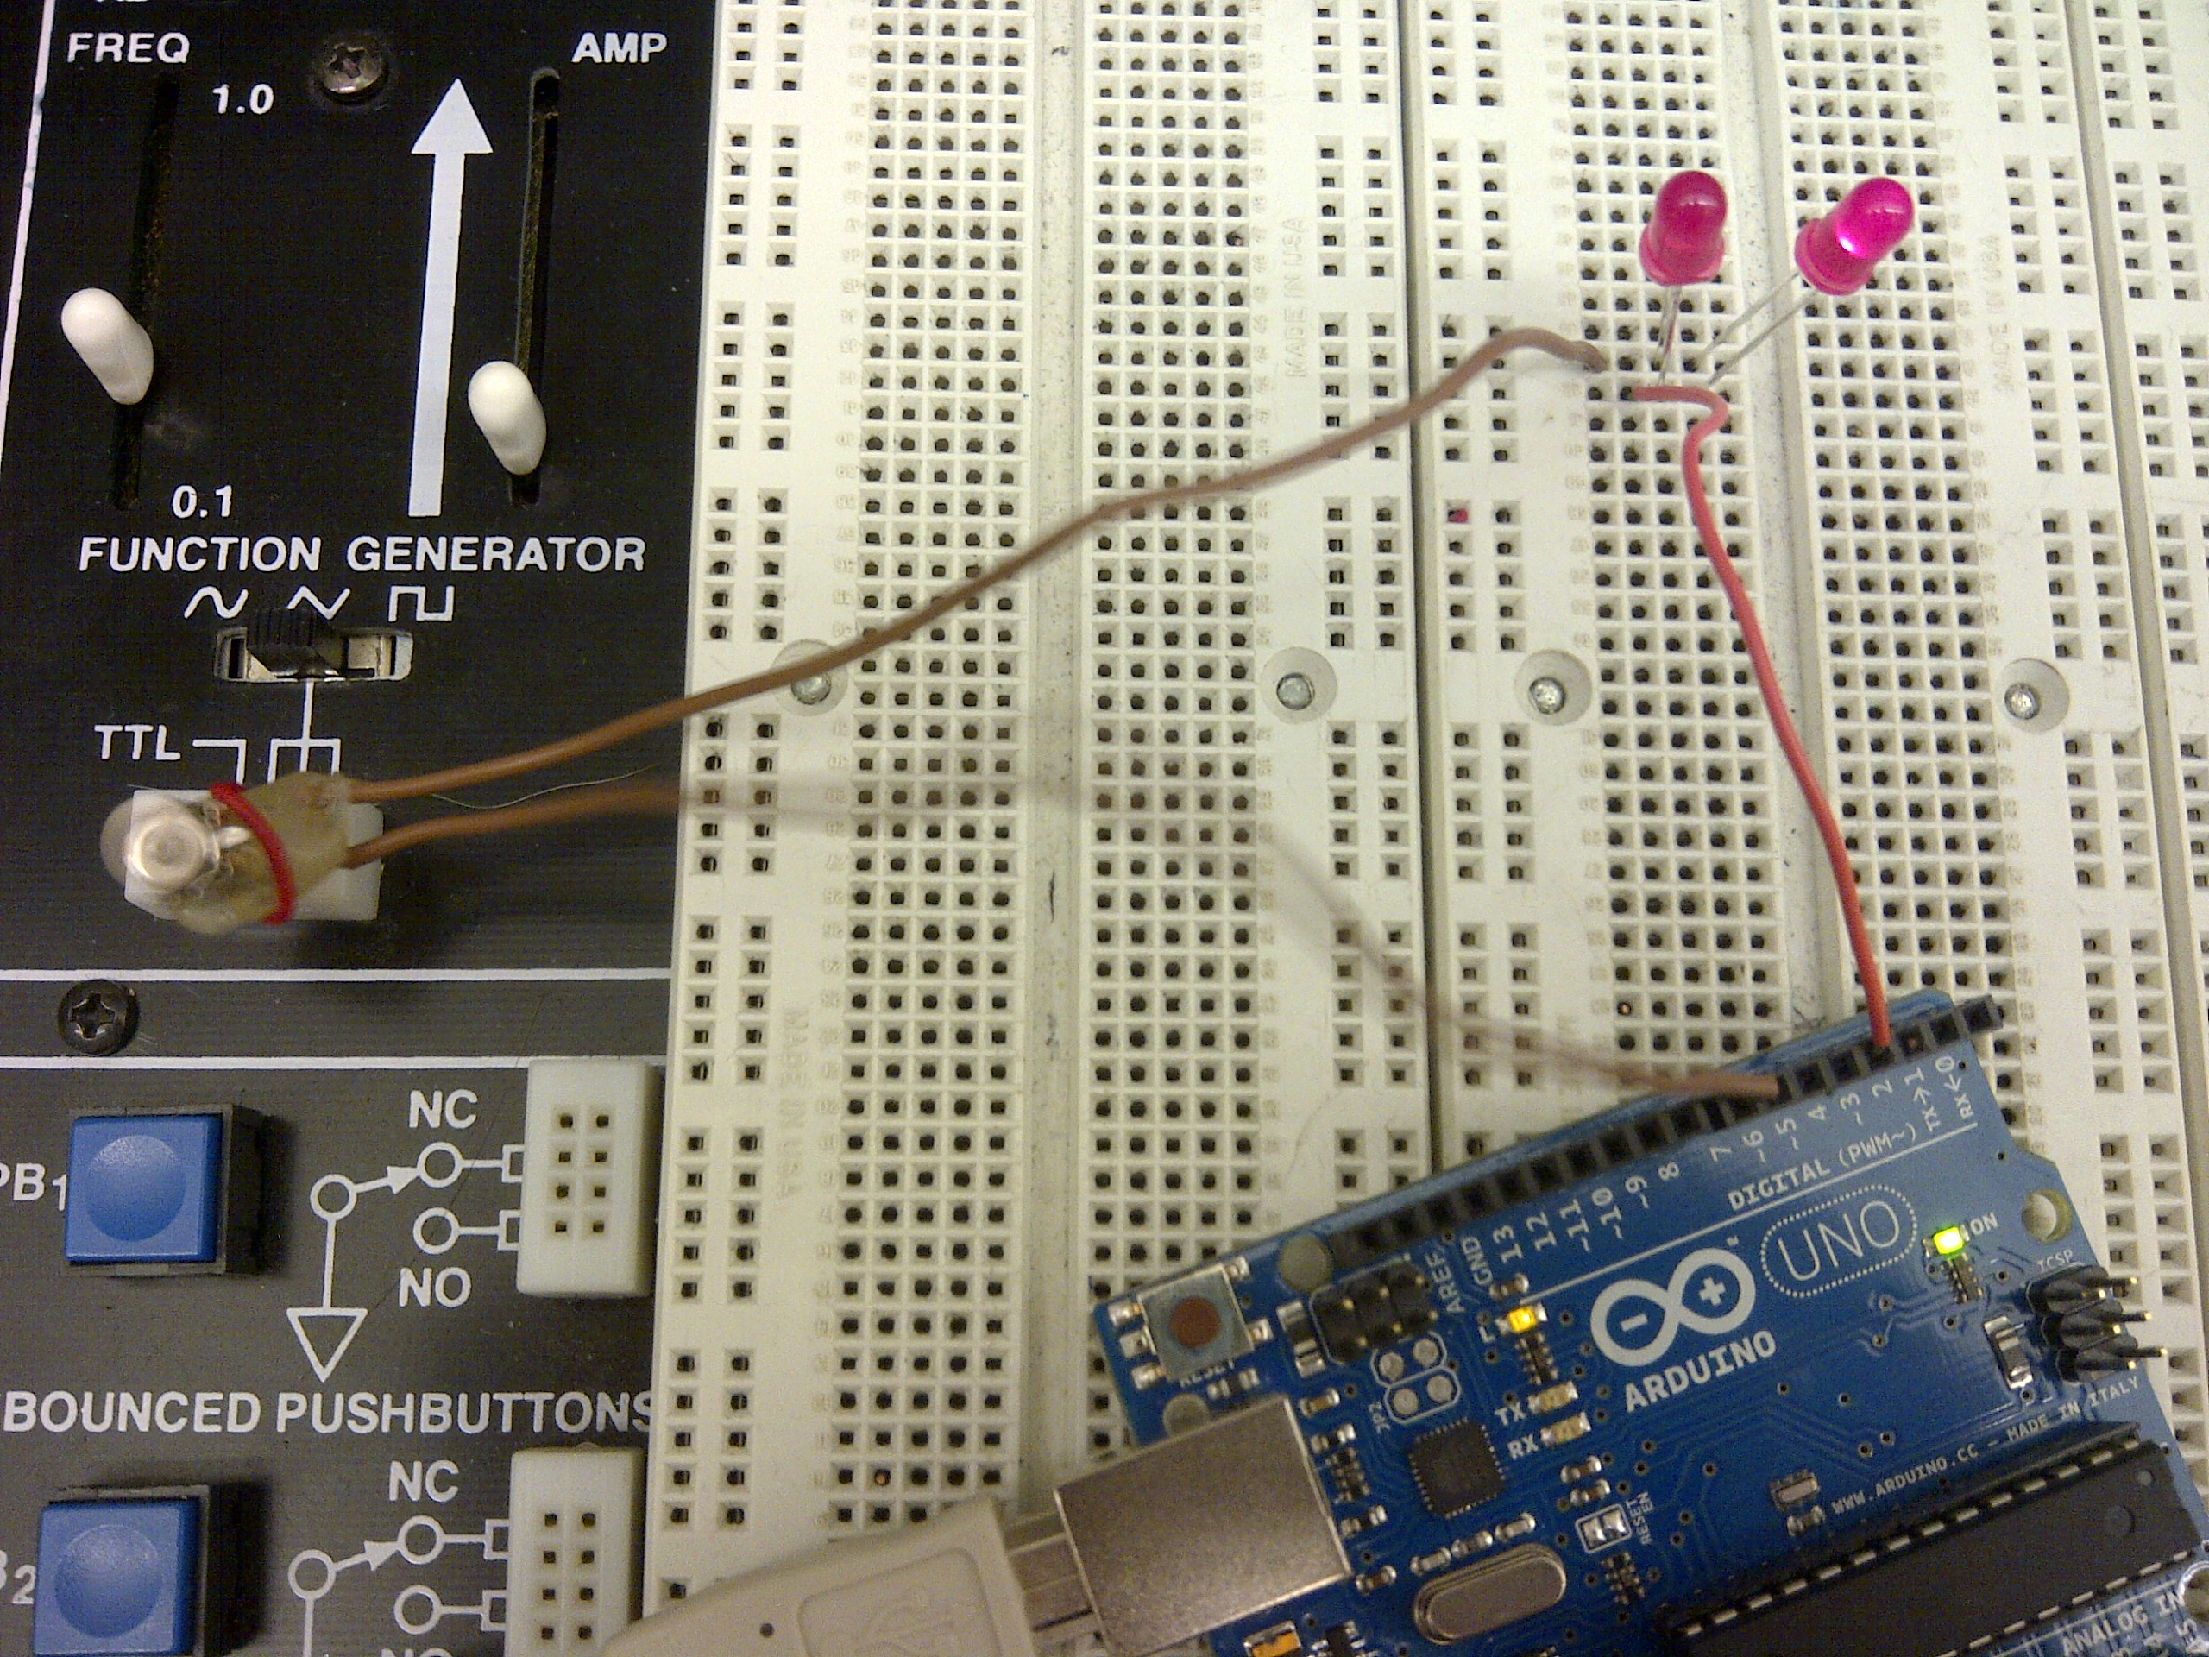

The LEDs served as both diodes and resisters (to prevent the full 5v from running through the engine.

Next, the students wrote a short program to convert the input from the serial interface into a value for the PWM duty cycle. The method involves taking a 3 digit number, multiplying the first digit by 100, the second digit by 10, and then adding all three digits together.

Here is a copy of the code:

/* Talen Phillips and Dustin Maclay

* EE107-01

* 12MAR2013

* “PWM Motor Speed and Direction Control”

*/

int PWMpin1 = 3;

int PWMpin2 = 6;

void setup()

{

Serial.begin(9600); // open the serial port at 9600 bps:

TCCR2B = TCCR2B & 0b11111000 | 0x07; // 1024 divider for tmr 2

pinMode(PWMpin1, OUTPUT);

pinMode(PWMpin2, OUTPUT);

}

void loop()

{

Serial.print("Enter Direction (0 or 1)");

// send data only when you receive data:

while (!Serial.available());

// read the incoming byte:

int dir = Serial.read();

Serial.println(dir-'0');

Serial.print("Enter Speed (use a 3 digit number 000-255)");

while (!Serial.available());

int x = Serial.read();

while (!Serial.available());

int y = Serial.read();

while (!Serial.available());

int z = Serial.read();

int PWMout = 100*(x-'0') + 10*(y-'0') + (z-'0');

Serial.println(PWMout);

if (dir == '0')

{

analogWrite(PWMpin1, PWMout);

digitalWrite(PWMpin2, LOW);

}

if (dir == '1')

{

analogWrite(PWMpin2, PWMout);

digitalWrite(PWMpin1, LOW);

}

}

Here is a screenshot of the running code.

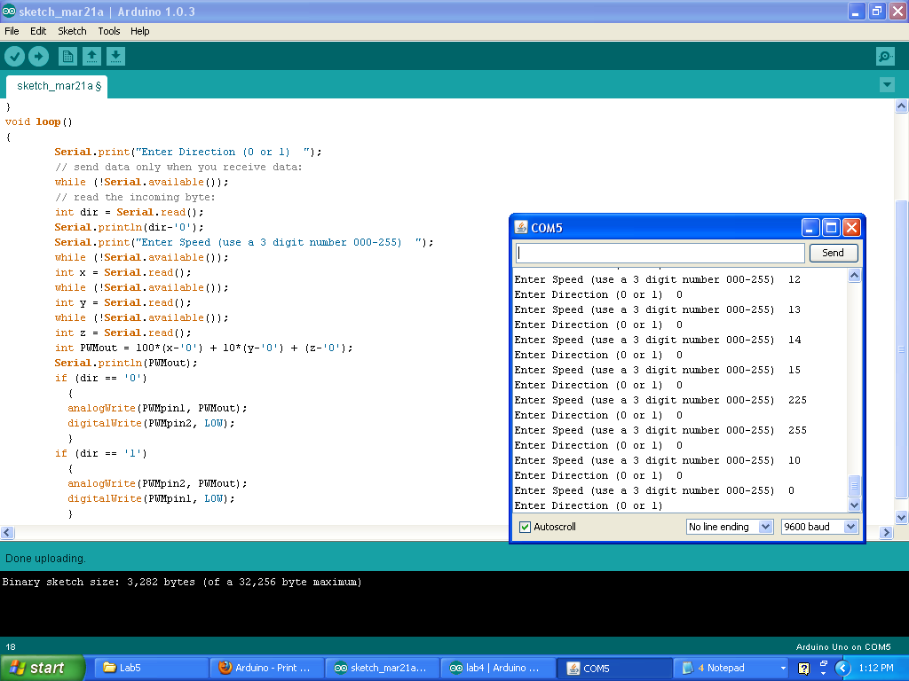

Three questions were posed to students:

Q) What is the minimum speed (0-255) commanded which allows your motor to turn starting from a zero speed condition?

A) The initial speed varied depending on the direction of spin and angle of the motor. This value was somewhere between 15-20.

Q) What is the minimum speed (0-255) commanded which allows your motor to turn starting from the speed found in part a)?

A) Once again, this number varied widely, but it was somewhere between 10 and 15, depending on direction and angle.

Q) If the two speeds in parts a) and b) are different, provide an explanation for the difference. If they are the same, explain why.

A) Most likely this was due to the difference between static friction and kinetic friction. That is to say, once an object begins sliding, the force required to maintain that slide will be less than the force required to start it. To be more specific, I would need to disassemble the motor to identify the sources of friction within the motor itself.

**Conclusion**

In this lab, the students learned how to use the Arduino microcontroller to take data from user input in the serial monitor. They used the data to control a PWM duty cycle in order to control a motor. The way the data was taken was a little awkward, since any letters would be accepted as values, and any input with less than 3 digits wouldn’t be used until the final digit was received. It may be possible to use an array to take an input of varying length and convert it into an integer, but since the standard C library isn’t included in its entirety (in particular, the atoi(); function is missing), the students would need to write their own function to execute that conversion.